Design Patterns and Principles
Exercise 1: Implementing the Singleton Pattern
FILE: Logger.java
public class Logger {
private static Logger instance;
private Logger() {
System.out.println("Logger instance created.");
}
public static Logger getInstance() {
if (instance == null) {
instance = new Logger();
}
return instance;
}
public void log(String message) {
System.out.println("LOG: " + message);
}
}
FILE: SingletonTest.java
public class SingletonTest {
public static void main(String[] args) {
Logger logger1 = Logger.getInstance();
Logger logger2 = Logger.getInstance();
logger1.log("Application Started");
logger2.log("User Logged In");
System.out.println("Logger1 HashCode: " + logger1.hashCode());
System.out.println("Logger2 HashCode: " + logger2.hashCode());
if (logger1 == logger2) {
System.out.println("Only one Logger instance exists.");
} else {
System.out.println("Multiple Logger instances exist.");
}
}
}

OUTPUT:
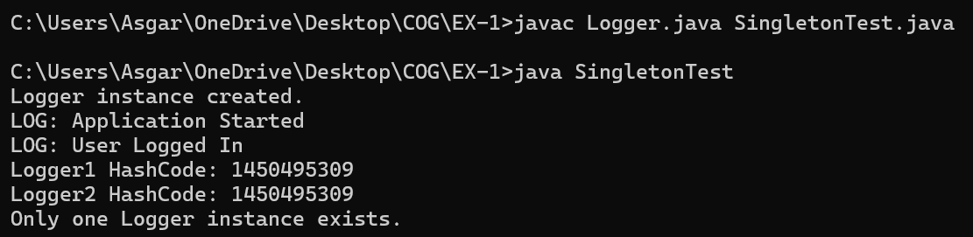

Exercise 2: Factory Method Pattern
File: FactoryMethodTest.java
interface Document {
void open();
}
class WordDocument implements Document {
public void open() {
System.out.println("Opening Word Document...");
}
}
class PdfDocument implements Document {
public void open() {
System.out.println("Opening PDF Document...");
}
}
class ExcelDocument implements Document {
public void open() {
System.out.println("Opening Excel Document...");
}
}
abstract class DocumentFactory {
public abstract Document createDocument();
}
class WordDocumentFactory extends DocumentFactory {
public Document createDocument() {
return new WordDocument();
}
}
class PdfDocumentFactory extends DocumentFactory {
public Document createDocument() {
return new PdfDocument();
}
}
class ExcelDocumentFactory extends DocumentFactory {
public Document createDocument() {
return new ExcelDocument();
}
}
public class FactoryMethodTest {
public static void main(String[] args) {
DocumentFactory wordFactory = new WordDocumentFactory();
Document wordDoc = wordFactory.createDocument();
wordDoc.open();
DocumentFactory pdfFactory = new PdfDocumentFactory();
Document pdfDoc = pdfFactory.createDocument();
pdfDoc.open();

DocumentFactory excelFactory = new ExcelDocumentFactory();
Document excelDoc = excelFactory.createDocument();
excelDoc.open();
}
}
OUTPUT:
